**Data Structure and Algorithms Lab**

**Code: PMDS605P**

**Digital Assignment 3**

**Name: Soumyadeep Ganguly**

**Reg. No.: 24MDT0082**

**Course: M.Sc. in Data Science**

**Implement Queue using Linked List in C.**

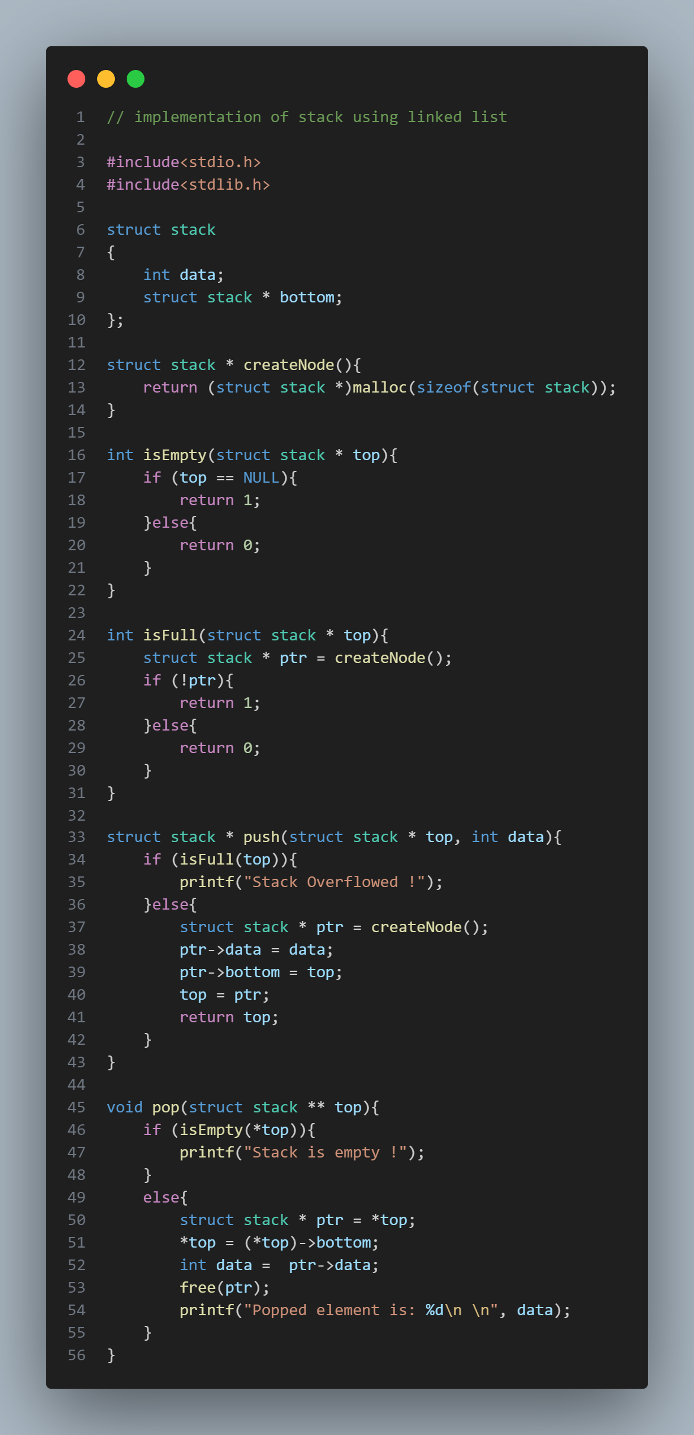

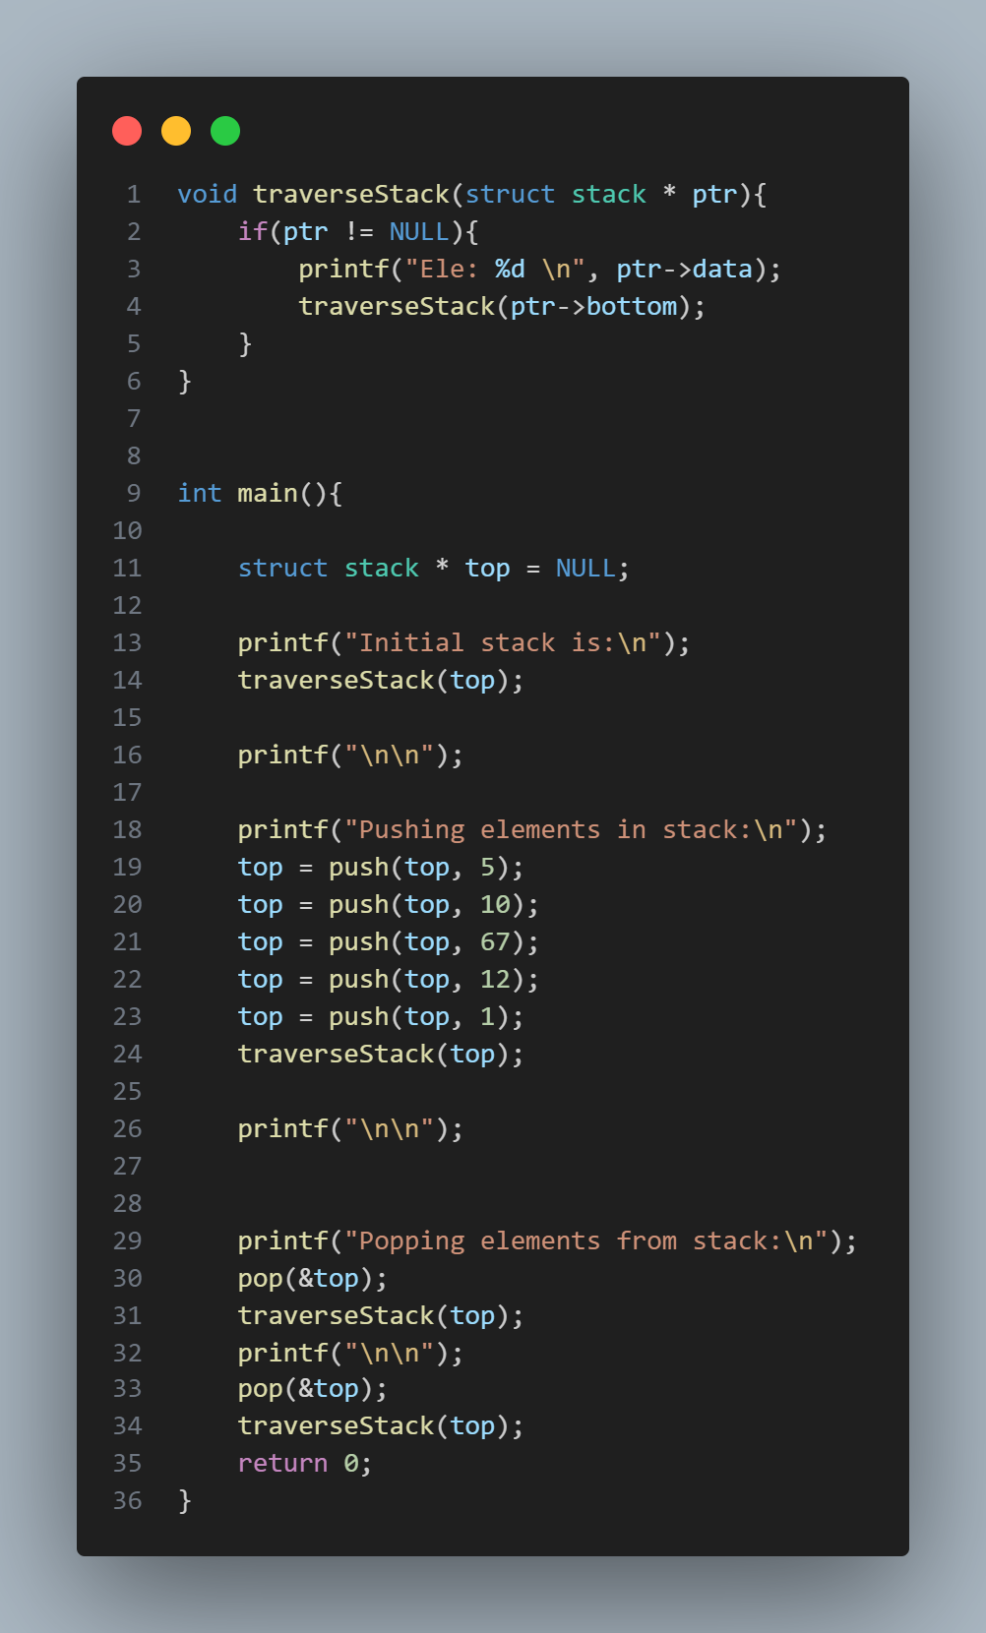

**OUTPUT:**

